2025 ICRA ELECTION CANDIDATE PROFILE

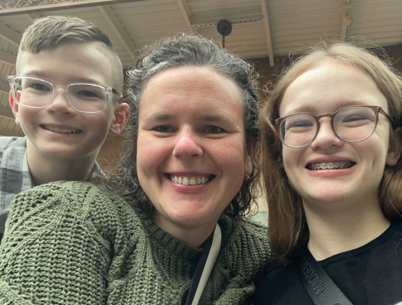
Name: Hanna Starr
Experience: Secretary 22-23 and 23-24, Vice President 42-25
Bio: I obtained my certification in 2019 while working at Schneck Medical Center. In early 2023 I became a full-time abstract or at Registry Partners where I currently work as a Quality Manager. I am also a mom to two wonderful kids and a fur baby!
I would love to serve as Vice President in order to better help not only those on the ICRA Board but all of the ICRA members. While I might not be the loudest voice in the room I will always support those who share in this wonderful career.

